**DAILY ONLINE ACTIVITIES SUMMARY**

|  |  |  |  |  |  |  |  |  |
| --- | --- | --- | --- | --- | --- | --- | --- | --- |
| **Date:** | **12/06/2020** | | | | | **Name:** | **Chandana Patil** | |
| **Sem & Sec** | **6th Sem and A Sec** | | | | | **USN:** | **4AL17CS020** | |
| **Online Test Summary** | | | | | | | | |
| **Subject** | | **No test** | | | | | | |
| **Max. Marks** | | **-** | | **Score** | | | **-** | |
| **Certification Course Summary** | | | | | | | | |
| **Course** | Cloud Foundation | | | | | | | |
| **Certificate Provider** | | | **Greatlearning** | | **Duration** | | | **6 Hours** |
| **Coding Challenges** | | | | | | | | |
| **Problem Statement:**  **1.** Python program to print the pattern.  **2.** Write a python program to implement Magic Square. | | | | | | | | |
| **Status: Completed** | | | | | | | | |
| **Uploaded the report in Github** | | | | | **yes** | | | |
| **If yes Repository name** | | | | | **https://github.com/chandanapatil/OnlineCourse.git** | | | |
| **Uploaded the report in slack** | | | | | **Yes** | | | |

**Certification:**



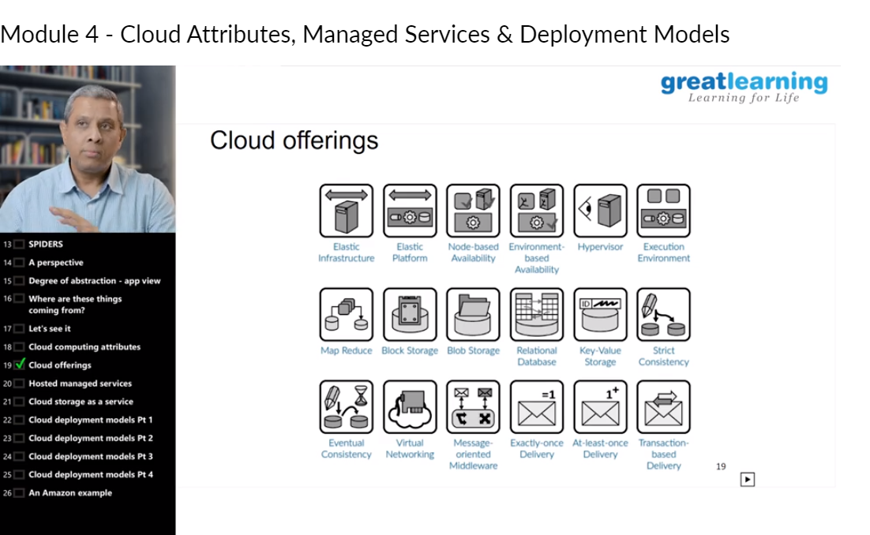

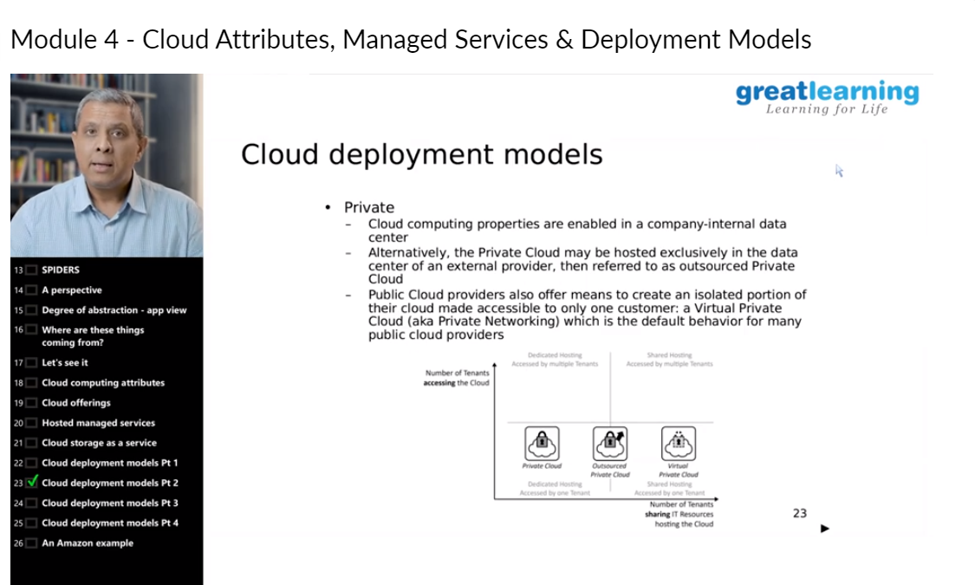

**OnlineCoding:**

**Prog1:** Python program to print the pattern.

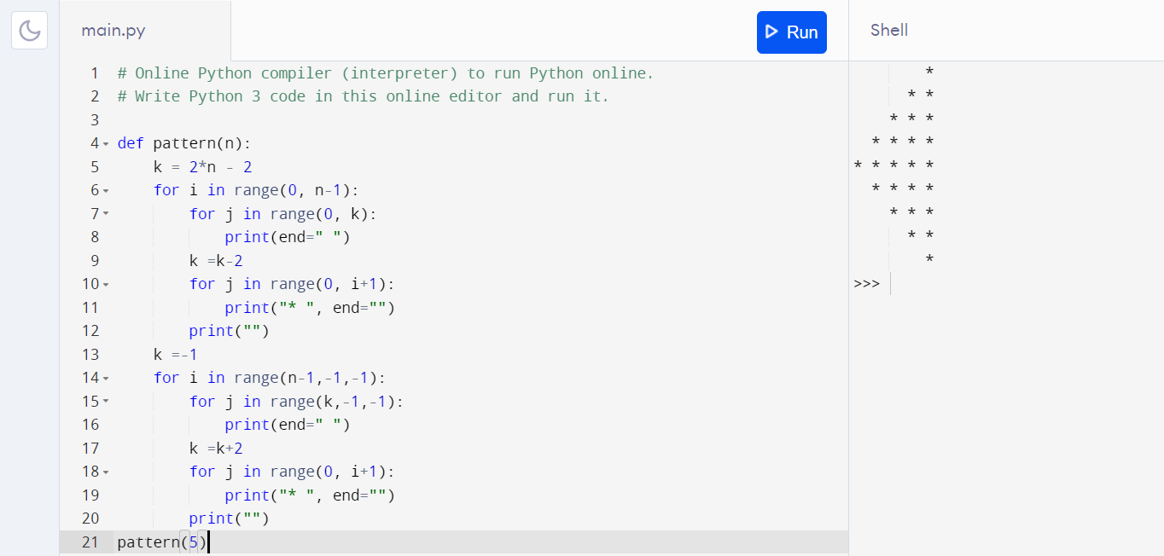

**Prog 2:** Write a python program to implement Magic Square.

Description: The constant sum in every row, column and diagonal is called the magic constant or magic sum, M. The magic constant of a normal magic square depends only on n and has the following value: M = n(n^2+1)/2.

